Kem Chan
CS 405 Secure Coding
Sept 25, 2026
Milestone – Unit Testing

Output
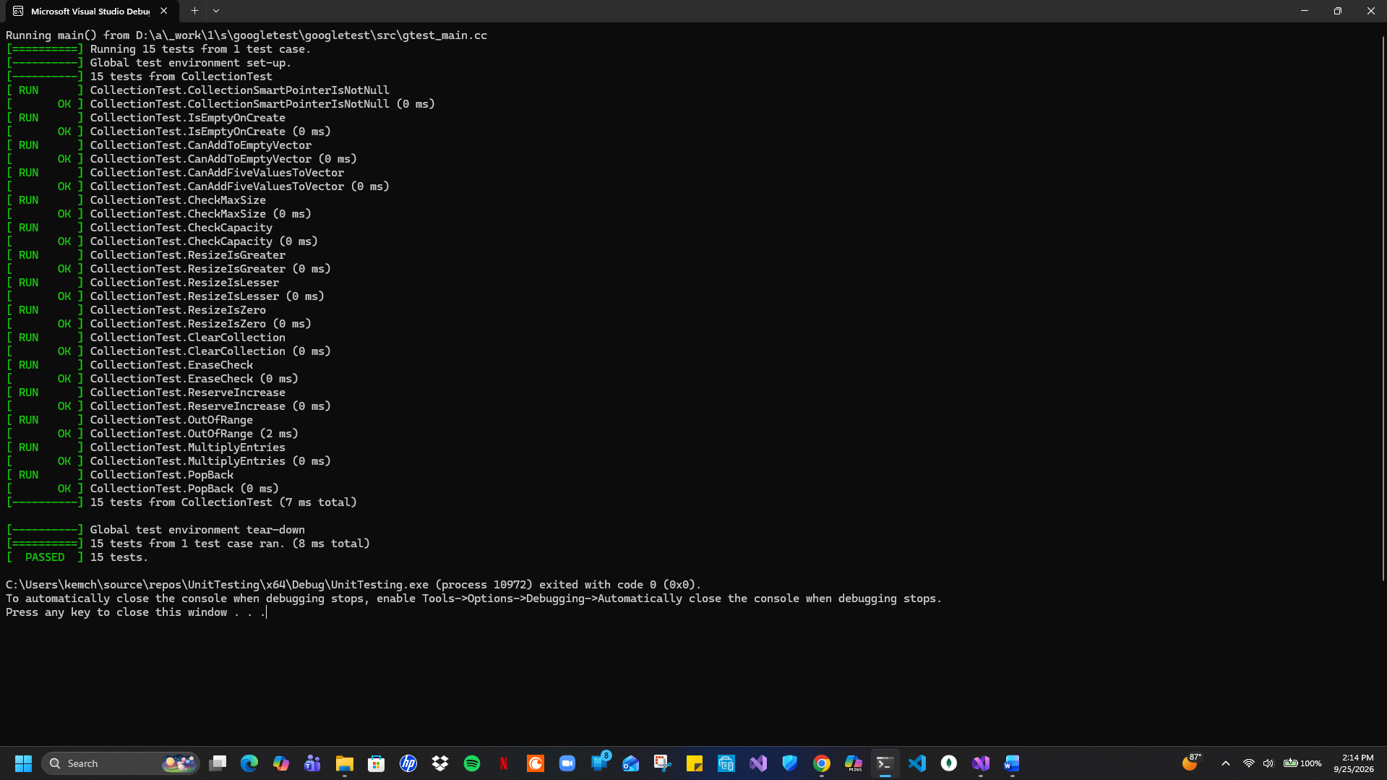
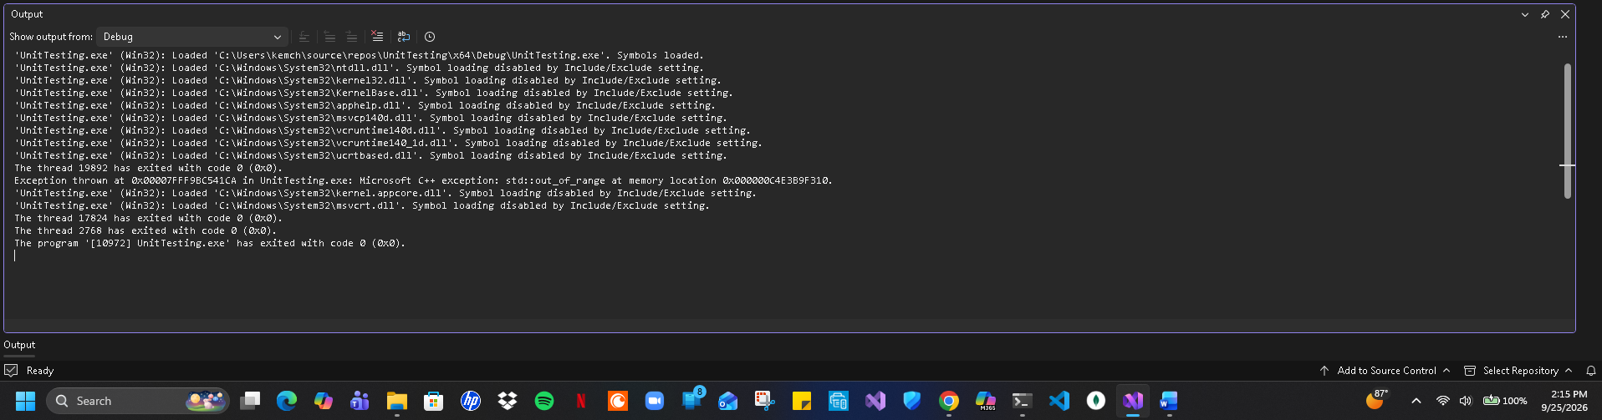
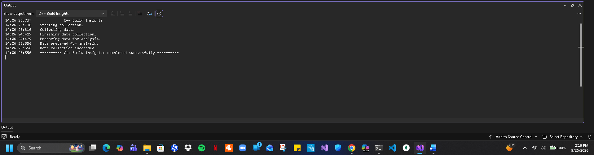

Summary
All the tests that were created were constructed to be appropriately named to convey what each specific test is attempting to verify. Each of the tests utilized ASSERT to ensure that everything was to be set up correct for the test. EXPECT was utilized to test and verify specific conditions of the test. There are some cases where a negative unit test was performed that the test would fail as expected in certain scenarios. The C++ programming functionality and best practices were followed with documenting the code and utilizing test fixtures in certain cases and parameterized test fixtures. Although the process of testing which was able to find issues that were divided by zero, length issues, and out of bounds issues.

